Aim:

To evaluate and enhance the usability, user satisfaction, and overall experience of the Superhero Training App, focusing on the interface's intuitiveness and engagement levels among users.

Procedure:

1. Identify Target Users:

- Select a diverse group of participants, including both novice and experienced app users interested in superhero training.

2. Define Key Metrics:

- Usability: Task completion time, error rate

- User Satisfaction: User feedback, Net Promoter Score (NPS)

- Engagement: Time spent on app, frequency of use

3. Design Test Scenarios:

- Scenario 1: Onboarding process and initial setup

- Scenario 2: Navigating through training modules

- Scenario 3: Tracking progress and achievements

- Scenario 4: Using advanced features like custom training plans

4. Conduct the Experiment:

- Preparation:

- Brief participants on the app’s purpose and how the testing will be conducted.

- Execution:

- Users perform tasks under observation.

- Record screen interactions and collect real-time feedback through interviews and surveys.

- Observation:

- Monitor user interactions, noting any difficulties or positive interactions.

5. Analyzing Data:

- Quantitative Analysis: Measure task completion rates, error rates, and engagement metrics.

- Qualitative Analysis: Summarize user feedback and identify recurring themes or issues.

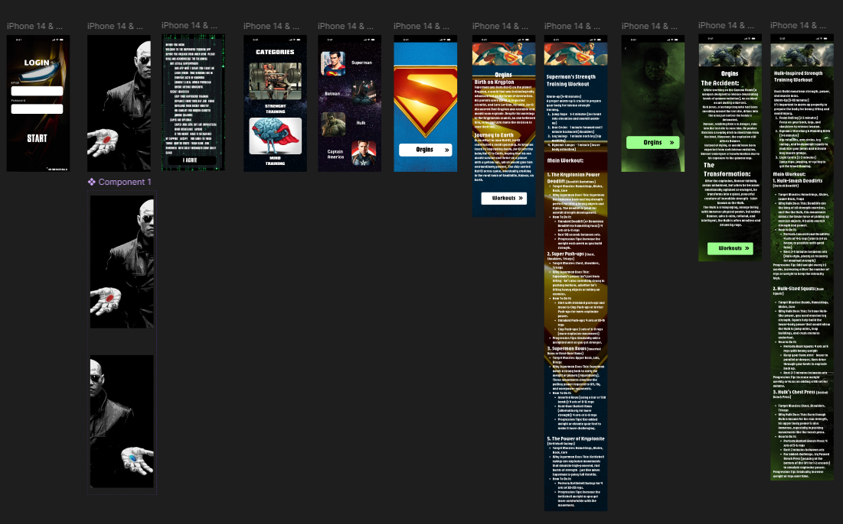

Result:

Based on the analysis, you might find:

- Strengths: Users found the onboarding process intuitive and engaging, and they appreciated the progress tracking features.

- Weaknesses: Some users struggled with navigating advanced features, indicating a need for clearer instructions or simplified interface elements.

- Actionable Insights:

- Simplify navigation for advanced features.

- Enhance tutorial and help sections.

- Introduce interactive guides to improve user onboarding.